**Web Server**

* Server refers to a computer or software solution where we can host, process and handle requests.
* Web Server resembles both hardware and software.
* It satisfies the client request by sending and receiving data.
* Web Server is responsible for hosting your applications, process and handling requests in Web.
* Web Server is also known as Http Server.
* The popular web server software
  + Microsoft IIS [Internet Information Services Manager]
  + Apache Tomcat
  + Node.js
  + NGINX
  + Lighttpd etc.
* We are going to use the webserver locally our machine, web build application, test, and then we can deploy on live servers.

**Windows Web Server**

* Windows OS comes with a webserver called “Internet Information Services”
* **Locate the Web Server on your windows PC**.
  + Open windows control panel
  + Switch to “Large Icon” view
  + Go to “Administrative Tools”
  + Look for “Internet Information Services Manager”
* **Add web server to your windows PC if not available**
  + Go to Control Panel
  + Open “Programs and Features”
  + Click on “Turn Windows Features ON or OFF”
  + Select “Internet Information Services”
  + Click OK
* **Test Web Server**
  + Open any browser
  + Request the following URL  
    <http://localhost>

<http://127.0.0.1>

**Web Site**

* Web is virtual directory on Web Server.
* It provides access to the resources.
* Web [Portion of Internet]
* Site [Location – usually in computing system location is referring to drive and directory]
* **Create a new Website on your local server**
  + Open IIS [run – inetmgr]
  + Expand local computer [http://localhost]
  + Expand “Sites” folder
  + Right click on “Default Web Site”
  + Select the option “Add Virtual Directory”

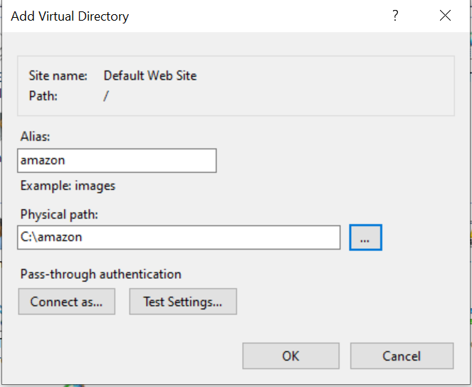

Alias: Web Site Name [http://localhost/amazon]

Physical Path: Resource Location [C:\amazon]

**Web Page**